EXP-2: FORMAL DESIGN OF AN EMBEDDED CONTROLLER USING STATE MACHINE (STATECHART) MODELING – TRAFFIC LIGHT CONTROLLER.
CODE:
// ----------------------------------------------------
// Formal Design of Embedded Controller Using FSM
// Traffic Light Controller
// Arduino UNO + Proteus
// ----------------------------------------------------

enum TrafficState
{
STATE_NS_GREEN,
STATE_NS_YELLOW,
STATE_EW_GREEN,
STATE_EW_YELLOW
};

TrafficState currentState = STATE_NS_GREEN;

// North-South traffic signal
const int NS_RED_PIN = 2;
const int NS_YELLOW_PIN = 3;
const int NS_GREEN_PIN = 4;

// East-West traffic signal
const int EW_RED_PIN = 5;
const int EW_YELLOW_PIN = 6;
const int EW_GREEN_PIN = 7;

void setup()
{
pinMode(NS_RED_PIN, OUTPUT);
pinMode(NS_YELLOW_PIN, OUTPUT);
pinMode(NS_GREEN_PIN, OUTPUT);

pinMode(EW_RED_PIN, OUTPUT);
pinMode(EW_YELLOW_PIN, OUTPUT);
pinMode(EW_GREEN_PIN, OUTPUT);

Serial.begin(9600);
}

void allOff()
{
digitalWrite(NS_RED_PIN, LOW);
digitalWrite(NS_YELLOW_PIN, LOW);
digitalWrite(NS_GREEN_PIN, LOW);

digitalWrite(EW_RED_PIN, LOW);
digitalWrite(EW_YELLOW_PIN, LOW);
digitalWrite(EW_GREEN_PIN, LOW);
}

void enterState(TrafficState state)
{
allOff();

switch (state)
{
case STATE_NS_GREEN:

digitalWrite(NS_GREEN_PIN, HIGH);
digitalWrite(EW_RED_PIN, HIGH);

Serial.println("STATE S0: NS GREEN - EW RED");

break;

case STATE_NS_YELLOW:

digitalWrite(NS_YELLOW_PIN, HIGH);
digitalWrite(EW_RED_PIN, HIGH);

Serial.println("STATE S1: NS YELLOW - EW RED");

break;

case STATE_EW_GREEN:

digitalWrite(NS_RED_PIN, HIGH);
digitalWrite(EW_GREEN_PIN, HIGH);

Serial.println("STATE S2: NS RED - EW GREEN");

break;

case STATE_EW_YELLOW:

digitalWrite(NS_RED_PIN, HIGH);
digitalWrite(EW_YELLOW_PIN, HIGH);

Serial.println("STATE S3: NS RED - EW YELLOW");

break;
}
}

void loop()
{
switch (currentState)
{
case STATE_NS_GREEN:

enterState(STATE_NS_GREEN);
delay(10000);
currentState = STATE_NS_YELLOW;

break;

case STATE_NS_YELLOW:

enterState(STATE_NS_YELLOW);
delay(3000);
currentState = STATE_EW_GREEN;

break;

case STATE_EW_GREEN:

enterState(STATE_EW_GREEN);
delay(10000);
currentState = STATE_EW_YELLOW;

break;

case STATE_EW_YELLOW:

enterState(STATE_EW_YELLOW);
delay(3000);
currentState = STATE_NS_GREEN;

break;
}
}
OUTPUT:
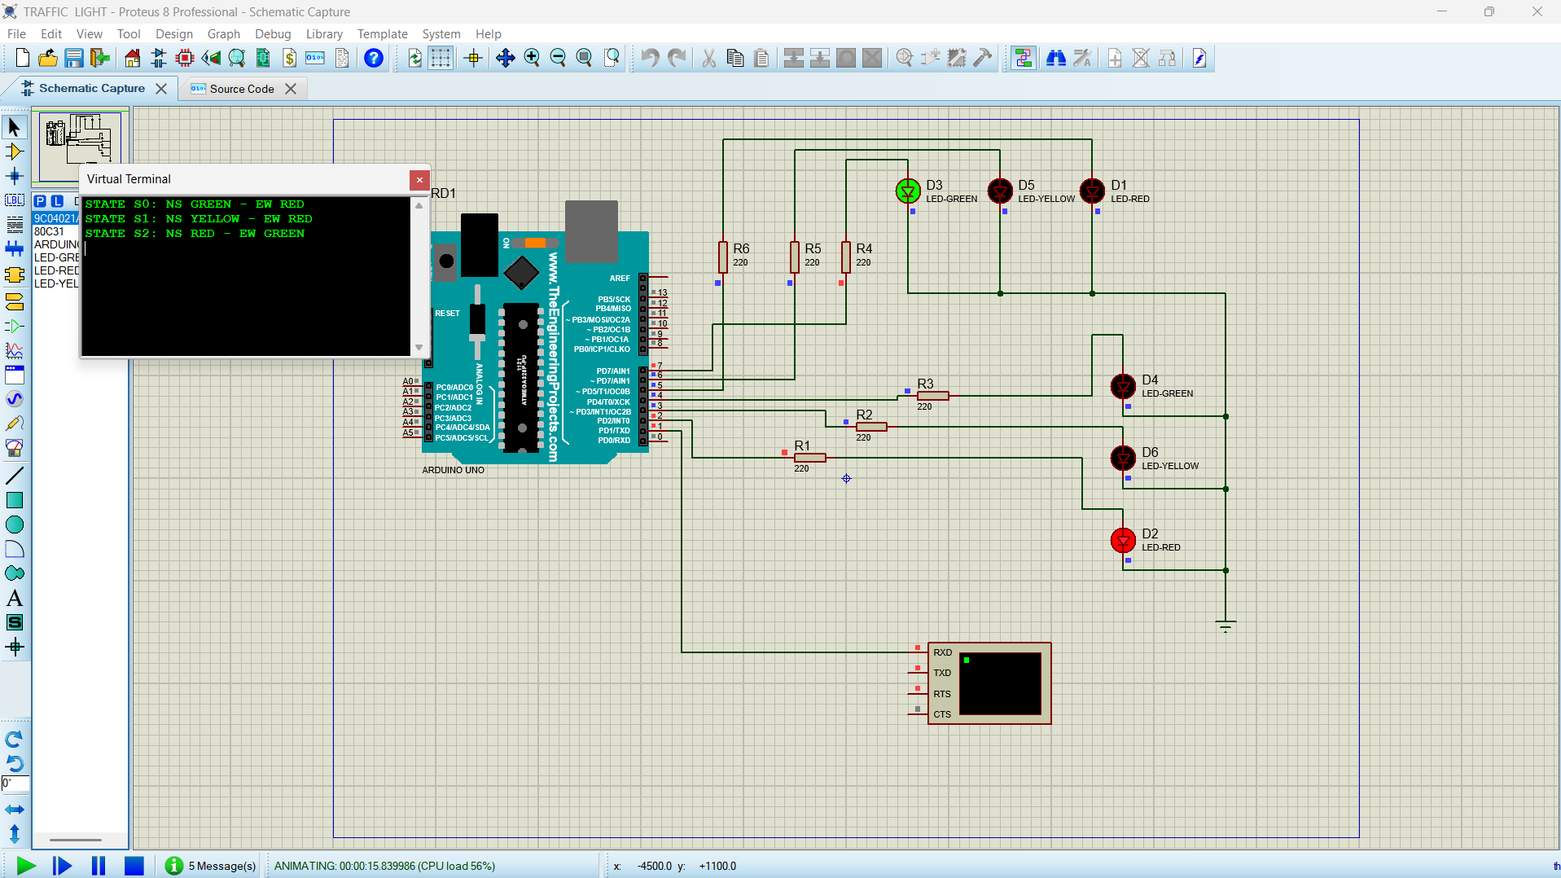

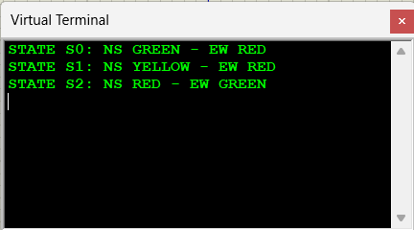
REFLECTION: I learned about FSM concepts and traffic light state transitions. I understood Arduino UNO interfacing and Proteus simulation. I verified the traffic light sequence and timing conditions.

